**

**Shivnagar Vidya Prasarak Mandal’s**

**COLLEGE OF COMMERCE, SCIENCE AND COMPUTER EDUCATION**

**Malegaon (Bk.), Tal:-Baramati, Dist:-Pune.**

**Pin:-413115, Ph :-( 0212)-254214, Fax:-254424.**

**CERTIFICATE**

**[Session 2017-2018]**

**This is to certify that project report entitled,**

**“AGRO SHOP BILLING SYSTEM”**

**Submitted in the partial fulfillment of the requirement for the award of the BACHELOR OF COMPUTER SCIENCE OF PUNE UNIVERSITY.**

**Mr. Ranaware Aditya Ramesh**

**Roll No: 947**

**T. Y. BSc. (Comp. Sci.)**

**PROF.PAWAR S. PROF. SASTE S. DR. R. G. PAWAR**

**(Project Guide) (HOD) (Principal)**



**Shivnagar Vidya Prasarak Mandal’s**

**COLLEGE OF COMMERCE, SCIENCE AND COMPUTER EDUCATION**

**Malegaon (Bk.), Tal:-Baramati, Dist.:-Pune.**

**Pin: 413115, Ph :-( 0212)-254214, Fax:-254424.**

**A**

**PROJECT REPORT**

**ON**

**“AGRO SHOP BILLING SYSTEM”**

**UNDER THE GUIDANCE OF**

**PROF. PAWAR S.**

**Submitted By**

**Mr. Ranaware Aditya Ramesh**

**Roll No: 947**

**T. Y. BSc. (Comp. Sci.)**

**ACKNOWLEDGEMENT**

I wish to express my sincere thanks to the Principal, Head of Computer Science Department, and all teaching and non-teaching staff. For their extraordinary help throughout period of my project.

We are thankful to Prof. Saste S. Head of Computer Science Department of CCSCE Malegaon (Bk.) College, Malegaon for making available all the required resources and co-operation in our project work.

It gives us great pleasure to express gratitude to Prof. Pawar S. for valuable guidance and suggestion while preparing this project**.**

We are especially thankful to those who helped us directly-indirectly in completion of this work successfully.

***Mr. Ranaware Aditya Ramesh(Roll no:-947)***

INDEX

|  |  |  |
| --- | --- | --- |
| Sr.No | Topic | Page No |
| 1. | Introduction | 2 |
| 2. | Scope and Objective | 3 |
| 3. | Need of Computerization | 4 |
| 4. | Existing System | 5 |
| 5. | Proposed System | 6 |
| 6. | Fact finding Techniques | 7 |
| 7. | Feasibility Study | 8 |
| 8. | System Requirement | 9 |
| 9. | Normalization | 10 |
| 10. | File Design | 11 |
| 11. | ER Diagram | 15 |
| 12. | UML Diagrams | 16 |
| 13. | I/O Screens | 22 |
| 14. | Testing Plan | 37 |
| 15. | Future Enhancement | 38 |
| 16. | Conclusion | 39 |

INTRODUCTION

* The Organization is mainly managed by store manager.
* All records are entered computerized.
* There are bill books are printed.
* This system is very efficient for purchasing, selling, and ordering of products.
* It is an easy to handle and thus implementing this software was necessity to reduce time in entering records.
* Computerized records it has reduced manual works which have been helpful in accurate and efficient storage of records like customers, supplier, employee, products etc. which is indirectly useful for the organization.
* In the varies types of Agricultural products like:
  + Pesticide
  + Seeds
  + Fertilizer

# SCOPE AND OBJECTIVES

## SCOPE:-

## This system is prepared by seeing the drawbacks and limitation in existing manual record storage, because of this computerized of this system was necessary.

## Manual work is very time consuming and lot of paper work is required in it. Hence to avoid error in report generation the computerization of this system was a need. Therefore the security level has been also increased.

## 

## This system has some following scope:-

## 1)Easy in search Record.

## 2)Highly efficient and accurate.

## 3)Reduces paper & manual work.

## 4)Storing details is quick and efficient.

## 5)Security for data.

## OBJECTIVES:-

With this aim of the proposed system it is easy and useful for the dealer to interact with the customer.

# NEED OF COMPUTERIZATION

Till today all the processing was done manually. All the readings were done manually in rough and copied later in individual test register. Suppose record of any student is checked after some period, they have to search in all registers. Since they may carry out nearly many tests, it becomes tedious to search manually.

Also if reading were to be changed to avoid tediousness, a new copy had to written down. It leads to the lot of paper work.

In proposed system, which is computerized, the result analysis and reports need not to be done manually but can obtain just on click of mouse.

Part of job by using computer system the work will be easy and lastly it reduces lot of calculation and Searching

# EXISTING SYSTEM

* It is time consuming process as the user has to type the dbase commands. He has to remember all the commands which are difficult.
* It is limited to a single system.
* A user who wants only to have some information has to contact the administrator every time.

# PROPOSED SYSTEM

The “Agro shop management system” is to be computerized in order to overcome the problems, which affects the existing manual system. Computerizing the existing System with help of visual basic programming, database package ease the work of the system up to a great extent.

In the computerized system the first screen of the system would be a welcome message. After than the login window open & then a list of menus are displays. These menus contain the information about employee, supplier, customer & products as well as it contain report & billing information.

After the transaction is completed the user can log off from the system by clicking on exit menu.

FACT FINDING TECHNIQUES

Fact finding technique is a process to collect information about the system requirements. There are four kinds of fact finding technique:

1) Interview.

2) Record Review.

3) Observation.

4) Questionnaire.

We have used following techniques:

**INTERVIEW**:-

Information, Suggestion, Underlying problems etc. In this this technique is used to collect information from individual or groups. It is a qualitative technique the interviewer collects information from interviews.

**RECORD REVIEW**:-

This technique believes in record than in people. Record review can take place at the beginning of the system study of comparing actual operation with what the records indicate record may include.

a) Written manual records.

b) Rules and Regulations.

**Observation Technique:-**

Through observation we can obtain firsthand information about how activities are carried out. Observations help us in finding & collecting information that can not be obtained by any other fact-finding methods.

**QUESTIONNAIRE**:-

Questionnaire is a technique of asking different kinds of questions for collecting required information. We have used few questions for making our project easier and simpler.

1) When do they order for product to supplier?

2) How are their records maintained?

3) Which kind of product do they keep for sale?

# FEASIBILITY STUDY

The main objective of feasibility study is to test the Technical, Operational and Economical feasibility of developing a computer system.

The feasibility of any system may be viewed from the following three methods:

* **Economic Feasibility** :-

It is the measure of cost effectiveness of the system. At present the system can use one person to operate so the labor charge is reduced and other charges for the facility along with maintenance cost is reduced.

Our system is less costly. There is no restriction for use high level or specific printer for printing bills or records slips. This system can install any lower cost machines.

* **Technical Feasibility** :-

The software is user friendly interactive. User of the system should have known required software knowledge. They have to be technically trained before this system is implemented. But here is not special training required. This system is portable. Technical guarantees of accuracy, reliability, ease of access and data security is assured.

* **Operational Feasibility** :-

The system is user friendly hence any person in the organization can operate or use the system. The system can provide correctly & timely information as required by the organizational personal.

# SYSTEM REQUIREMENT

Hardware and Software are the two sides of the one coin. That is software without hardware is of no use & hardware without software is also useless. So our system is divided into Hardware & Software requirements.

Hardware & Software specifications required smoothly running of the system are as follows:

**Hardware Requirements:**

|  |  |
| --- | --- |
| Processor | Intel core i3 |
| Moniter | Monochrome or color |
| Memory | 32 MB RAM |
| Printer | Any type of printer(Inkjet printer) |

**Software Requirements:-**

|  |  |
| --- | --- |
| Operating System | Linux |
| Front End | Java(Version: JDK 12.0.1) |
| Back End | MySOL |

# Normalization

It is the process of simplifying the relationship between the data element in the record. Through the normalization collection of data in the record structure is replaced by successive record structure that is simpler, predictable and manageable.

There are three techniques of normalization:

1. **First Normal Form**
2. **Second Normal Form**
3. **Third Normal Form**
4. **First Normal Form:-**

It is achieved when all the repeating removed so that a record is of the fixed length.

1. **Second Normal Form:-**

It is achieved when a record is of first normal form and each item in record is fully dependent on the primary key. (Primary Key: - It is the field in the database that is chosen by database designer to identify all other field of that database dependent on that field.)

1. **Third Normal Form:-**

It is achieved when transitive dependencies are removed from the record design.

# FILE DESIGN

* TABLE FOR ADMIN LOGIN

This table stores total information about the admin login.

|  |  |  |  |
| --- | --- | --- | --- |
| **NO** | **FIELD NAME** | **DATA TYPE** | **SIZE** |
| 1 | user | VARCHAR | 10 |
| 2 | pass | VARCHAR | 10 |
| 3 | email | VARCHAR | 20 |
| 4 | mob | VARCHAR | 10 |

* DATA STORES

|  |  |  |  |
| --- | --- | --- | --- |
| **user** | **pass** | **Email** | **mob** |
| Aditya | 1301 | adityaranaware1301@gmail.com | 8484865030 |

* TABLE FOR CUSTOMER DETAILS

This table stores total information about the customer .

|  |  |  |  |
| --- | --- | --- | --- |
| **NO** | **FIELD NAME** | **DATA TYPE** | **SIZE** |
| 1 | Cid | INT | 10 |
| 2 | CName | VARCHAR | 20 |
| 3 | CAddr | VARCHAR | 20 |
| 4 | CMbNo | VARCHAR | 10 |

* DATA STORES

|  |  |  |  |
| --- | --- | --- | --- |
| **CId** | **CName** | **CAddr** | **CMbNo** |
| 1 | Aditya Ranaware | Shindewadi | 8484865030 |
| 2 | Sachin Ghadage | Satara | 9146435251 |

* TABLE FOR PRODUCT DETAILS

This table stores total information about the product.

|  |  |  |  |
| --- | --- | --- | --- |
| **NO** | **FIELD NAME** | **DATA TYPE** | **SIZE** |
| 1 | PId | INT | 10 |
| 2 | PName | VARCHAR | 15 |
| 3 | Type | VARCHAR | 10 |
| 4 | Stock | INT | 10 |
| 5 | price | INT | 10 |

* DATA STORES

|  |  |  |  |  |
| --- | --- | --- | --- | --- |
| **PId** | **PName** | **Type** | **Stock** | **price** |
| 1 | Magnesium Sulphate | Fertilizer | 50 | 800 |
| 2 | Urja Watermelon | Seed | 10 | 1000 |
| 3 | Agro plus(100ml) | Pesticide | 10 | 100 |

* TABLE FOR BILL INFORMATION

This table stores total information about bill.

|  |  |  |  |
| --- | --- | --- | --- |
| NO | FIELD NAME | DATA TYPE | SIZE |
| 1 | BNo | INT | 10 |
| 2 | CId | INT | 10 |
| 3 | CName | VARCHAR | 20 |
| 4 | PId | INT | 10 |
| 5 | Date | DATE | 10 |
| 6 | Total | INT | 10 |

* DATA STORES

|  |  |  |  |  |  |
| --- | --- | --- | --- | --- | --- |
| BNo | CId | CName | PId | Date | Total |
| 1 | 2 | Sachin Ghadage | 5 | 03/03/2020 | 4700 |
| 2 | 1 | Aditya Ranaware | 6 | 09/03/2020 | 1000 |

**E-R DIAGRAM**



**CLASS DIAGRAM**



**OBJECT DIAGRAM**



**USE-CASE DIAGRAM**



**COLLABORATION DIAGRAM**



**ACTIVITY DIAGRAM**



**SEQUENTIAL DIAGRAM**



**HOME PAGE**



**ADMIN LOGIN**

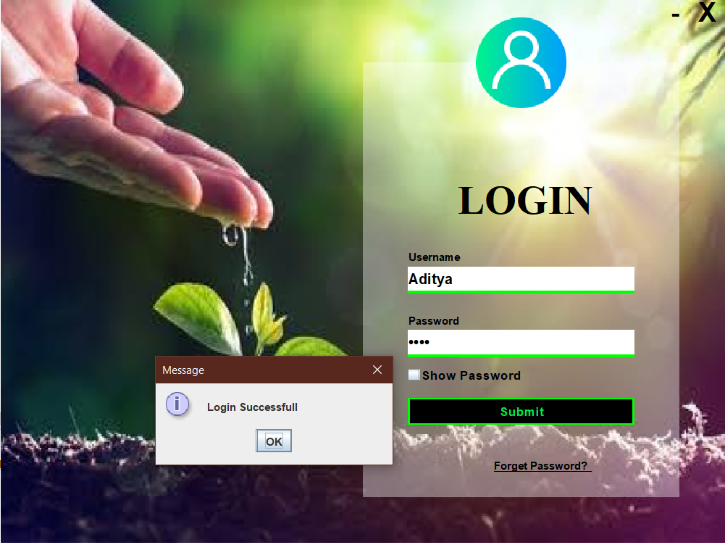

**FORGOT PASSWORD**

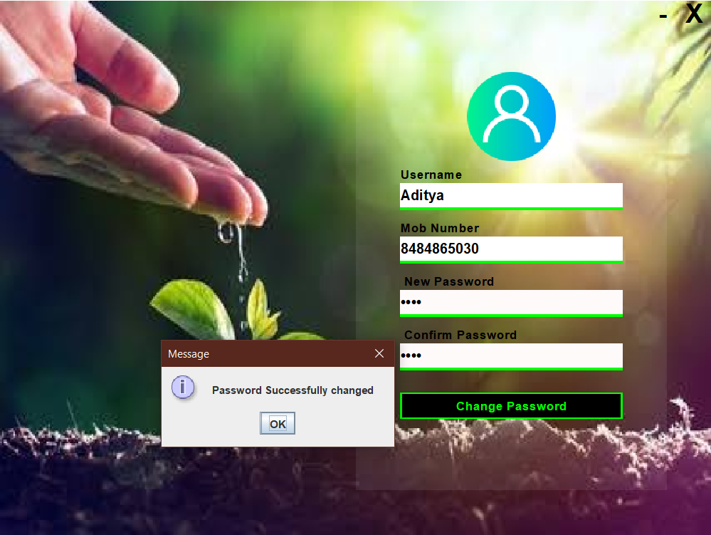

**MENU**

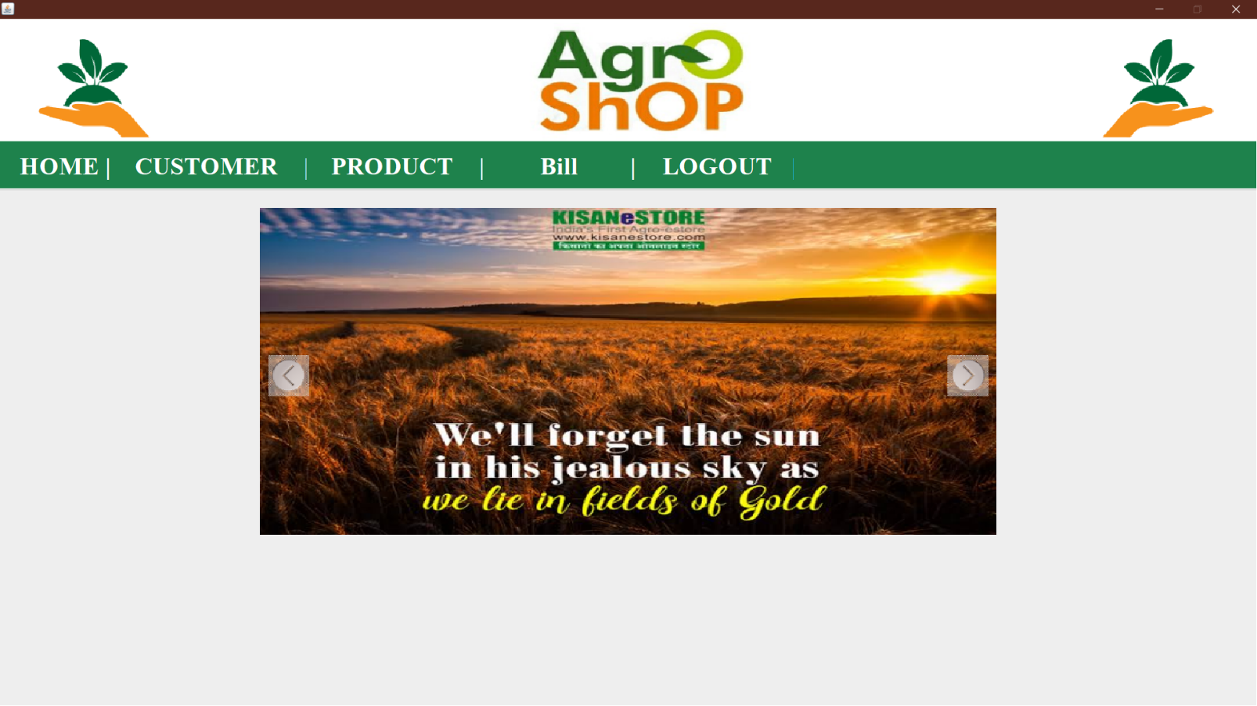

**ADD CUSTOMER**

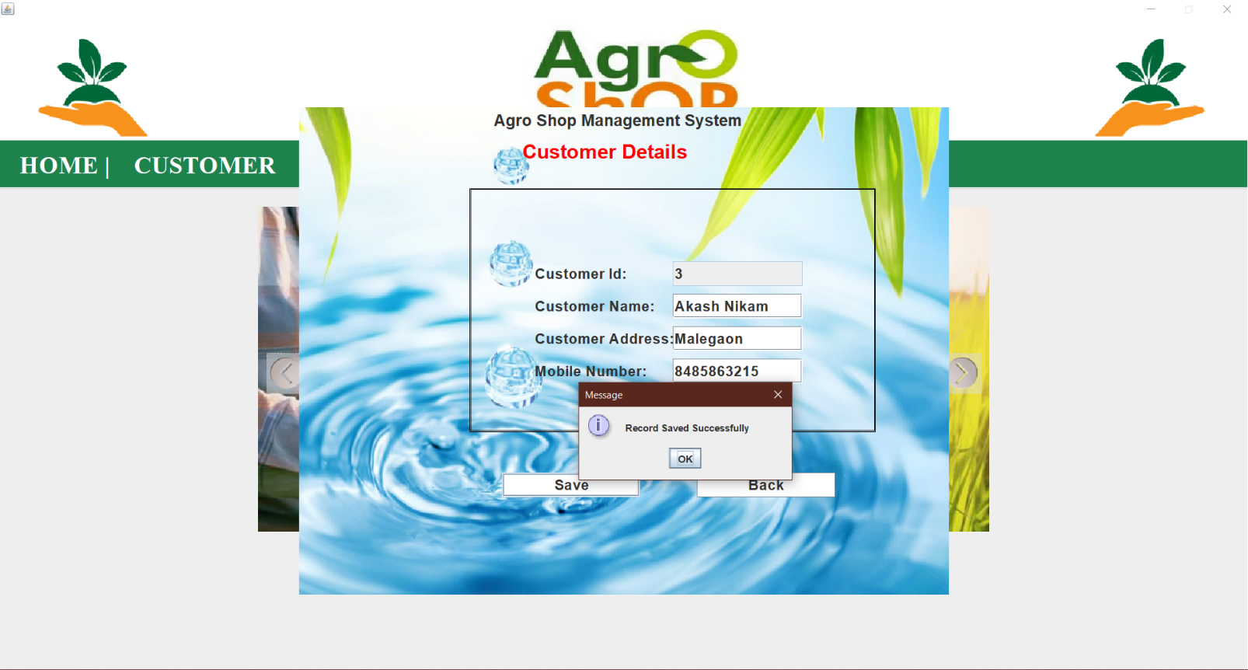

**SEARCH CUSTOMER**

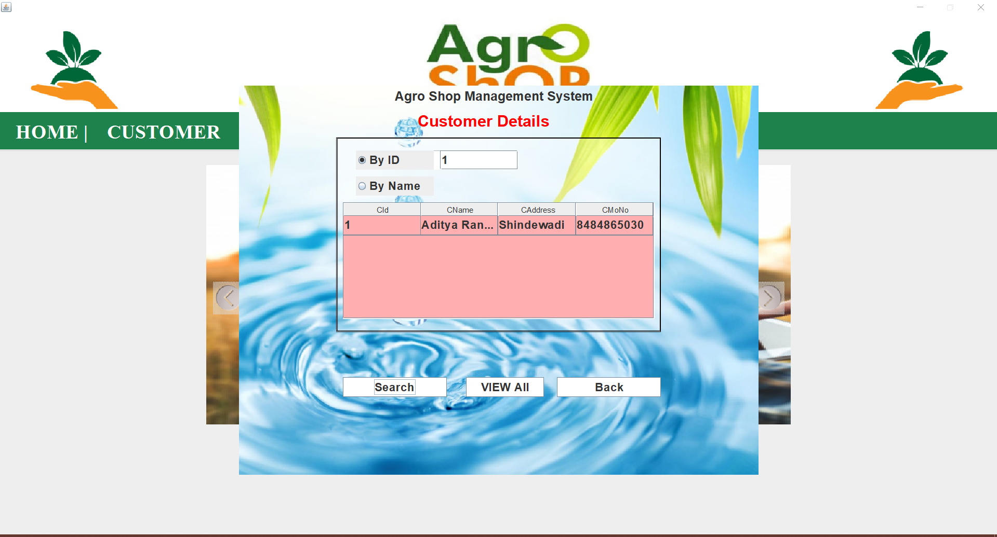

**UPDATE CUSTOMER**

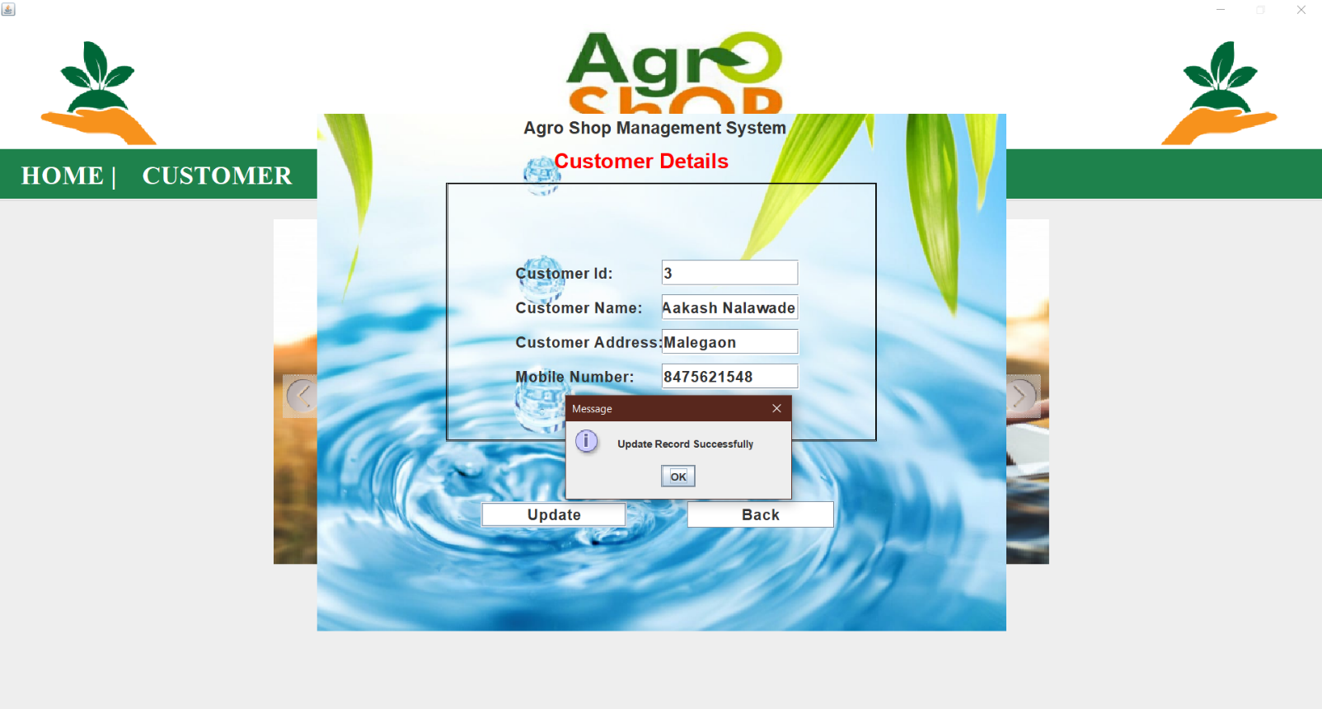

**ADD PRODUCT**

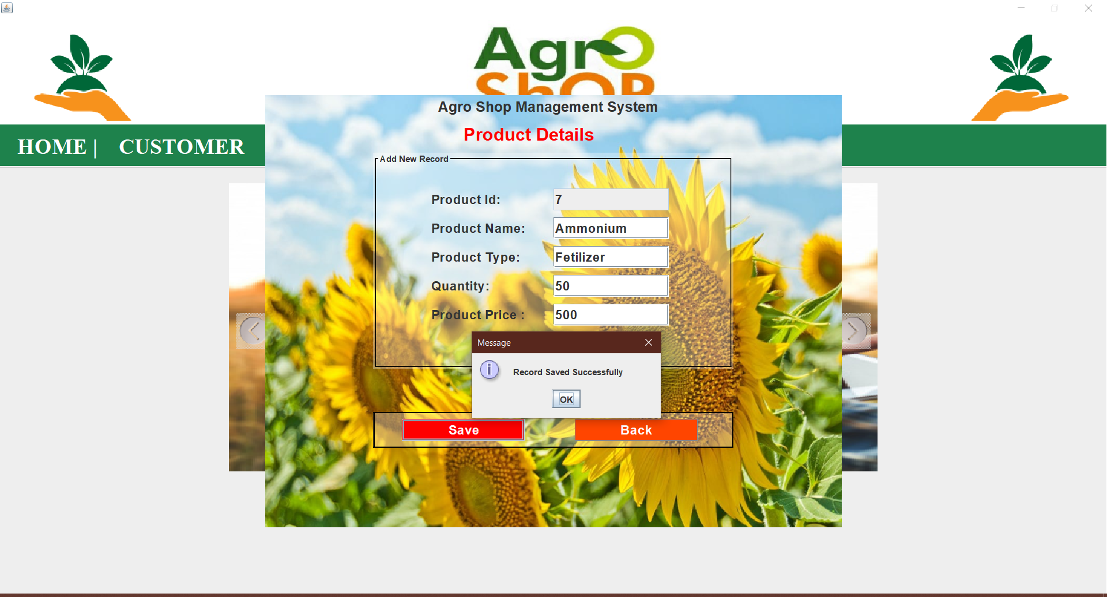

**SEARCH PRODUCT**

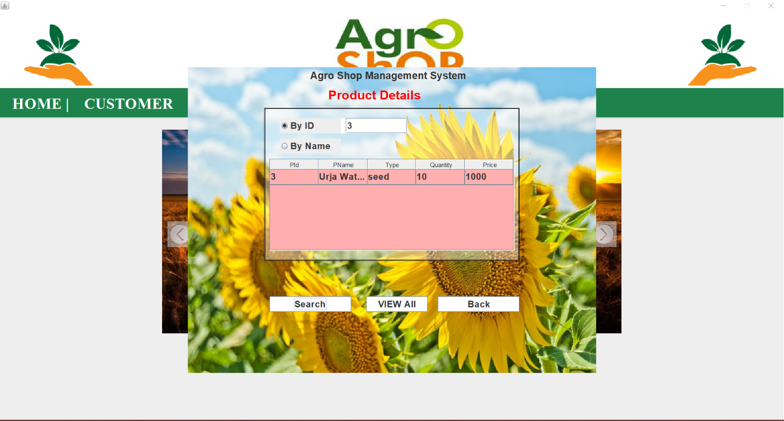

**UPDATE PRODUCT**

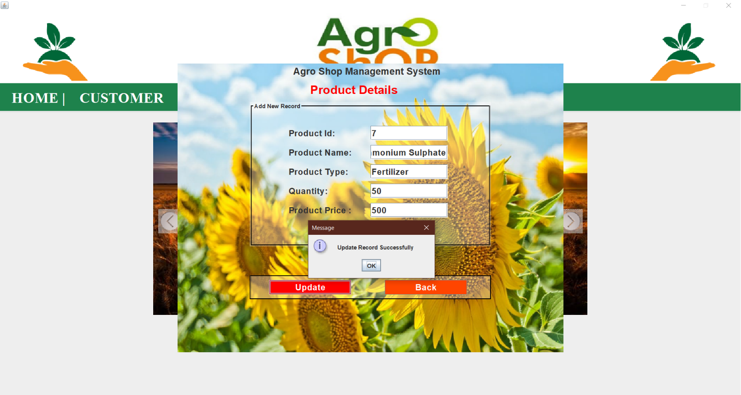

**DELETE PRODUCT**

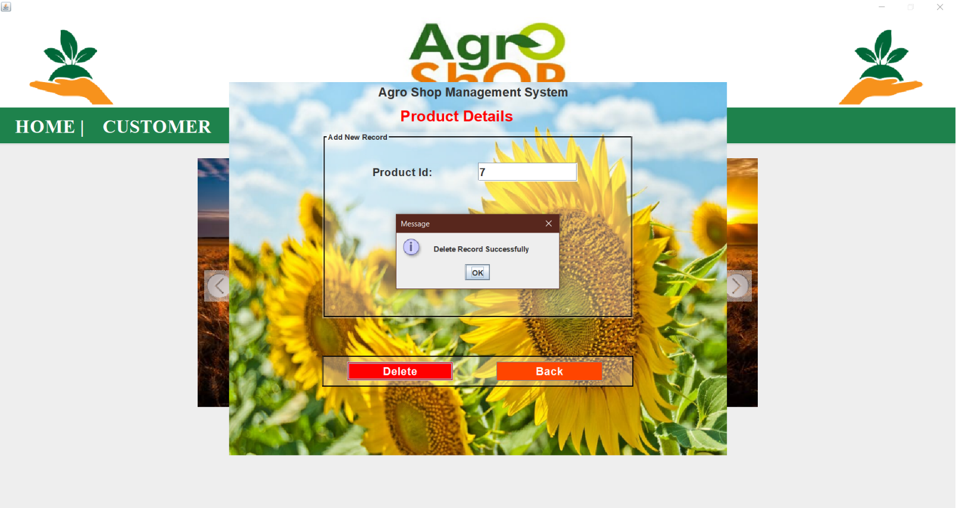

**CREATE BILL**

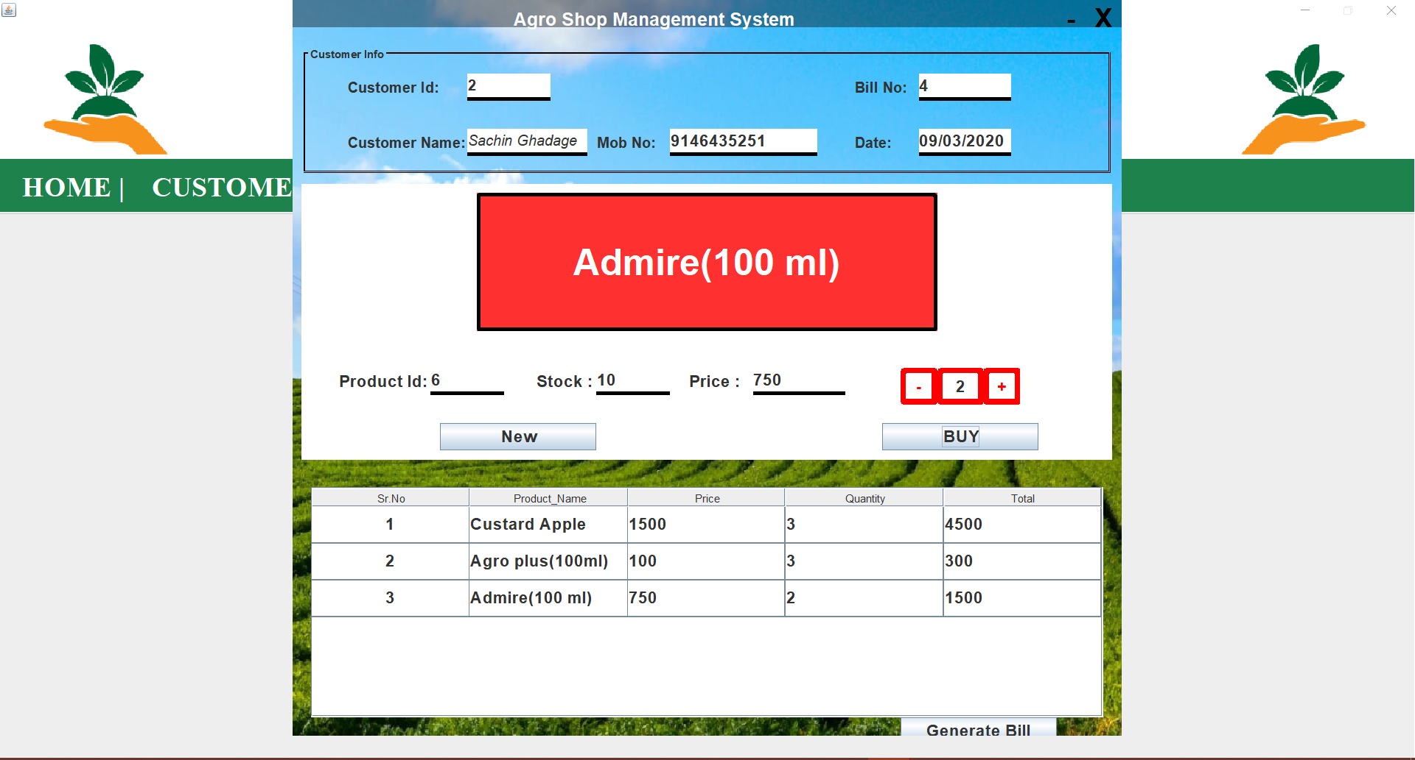

**GENERATE BILL**

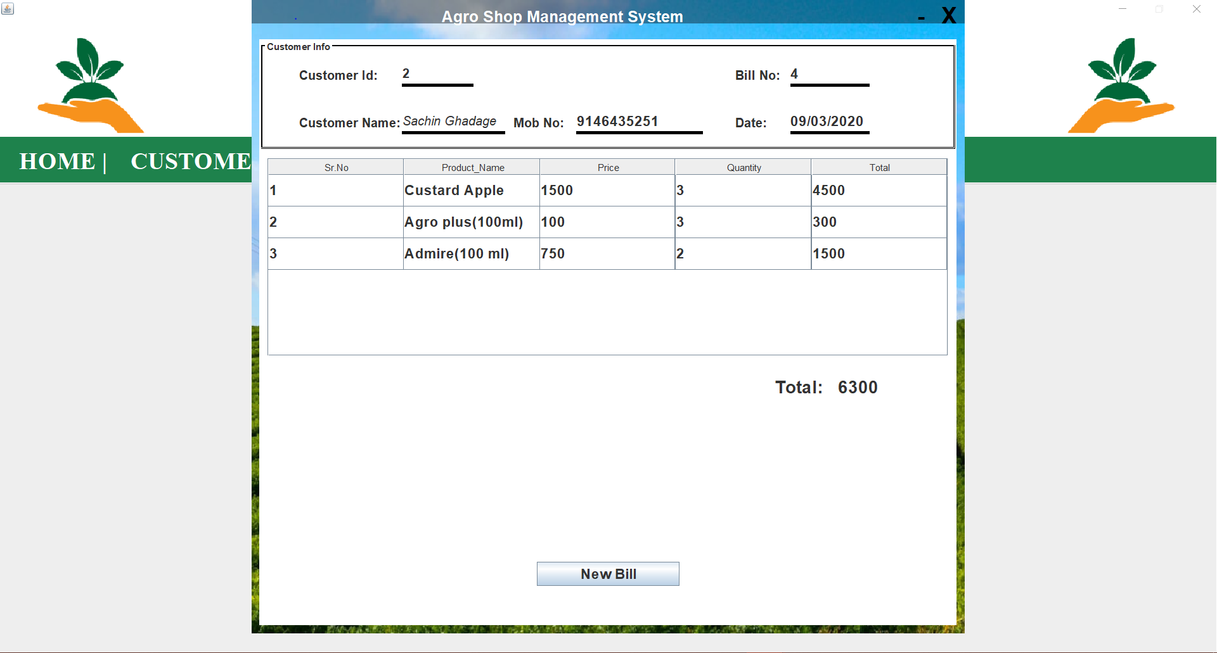

**CUSTOMER REPORT**

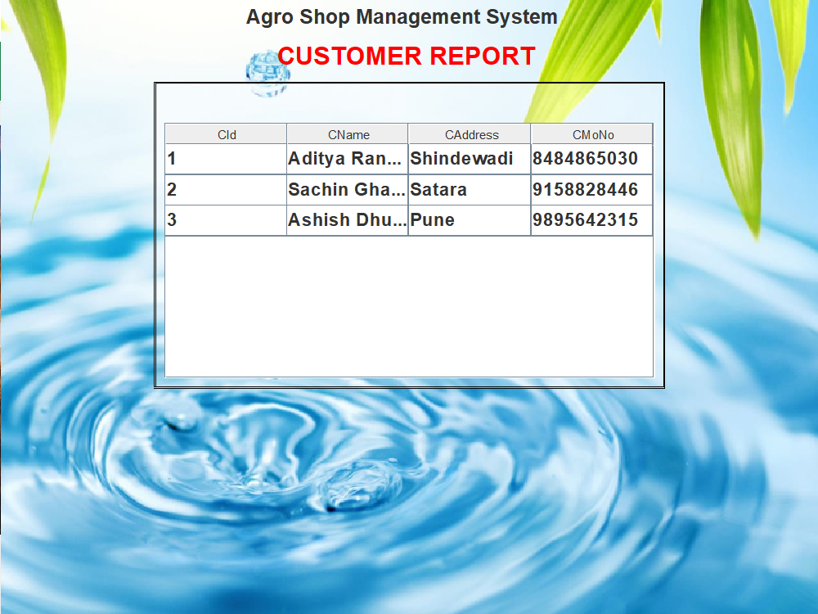

**PRODUCT REPORT**

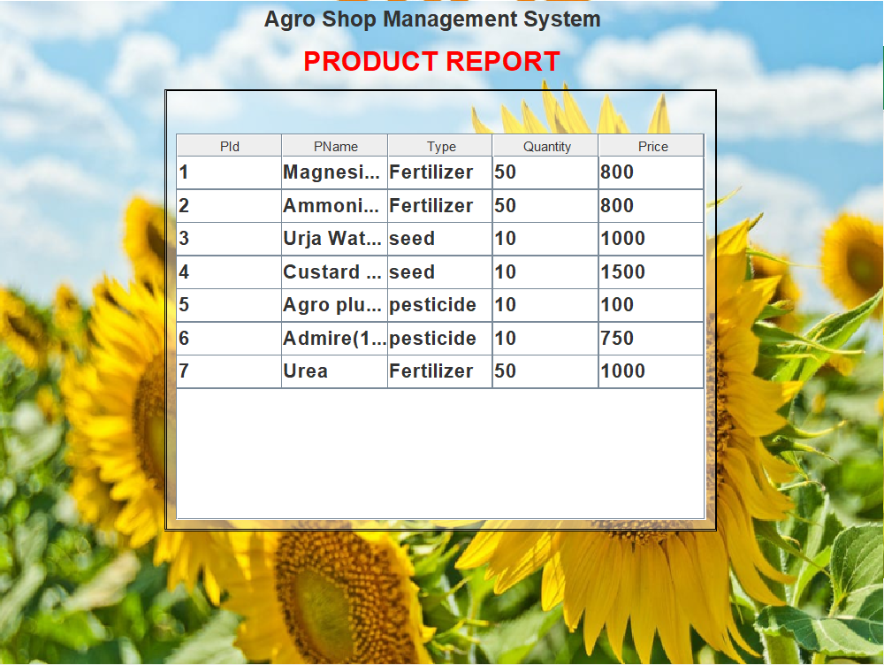

**BILL REPORT**

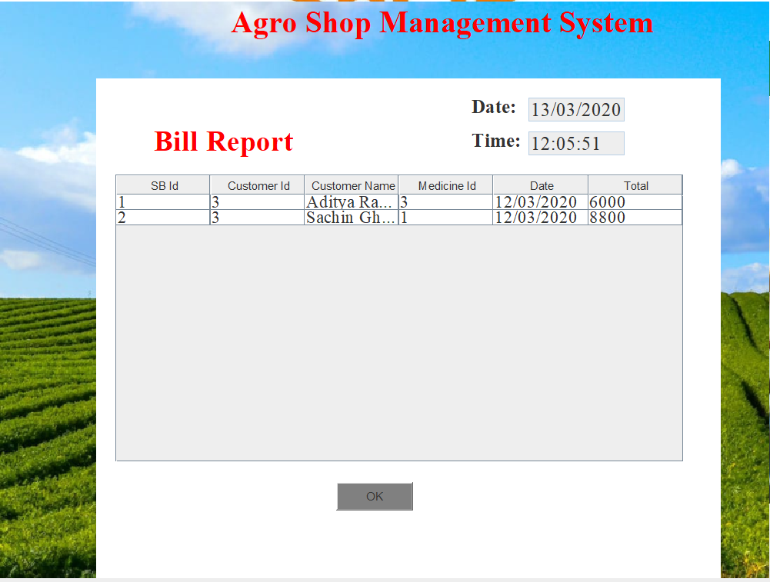

FUTURE ENHANCEMENT

This is the first system developed by me. It was great experience in such environment with professionals around me. After completion of project ”**AGRO SHOP BILLING SYSTEM**”, we try to satisfy maximum basic requirement of the admin. In future result can be directly printed ,and this functionality made available to user .This can be enhanced by giving the user more services such as aggregate calculations etc.

CONCLUSION

CONCLUSION

By using “**AGRO SHOP BILLING SYSTEM**”, analysis of bill will be easy and lastly it saves time and reduces complexity.